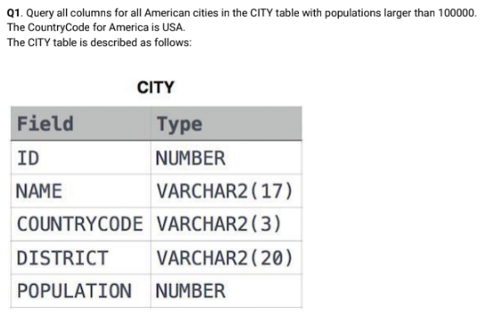

**Answer:**

create table city

(

id integer,

name varchar(17),

countrycode varchar(3),

district varchar(20),

population int

);

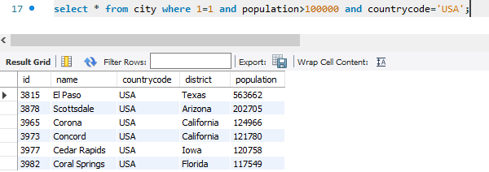

**Q2. Query the NAME field for all American cities in the CITY table with populations larger than 120000.**

**The CountryCode for America is USA.**

**Answer:**

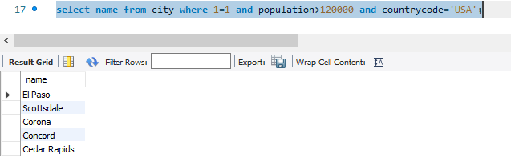

**Q3. Query all columns (attributes) for every row in the CITY table.**

**Answer:**

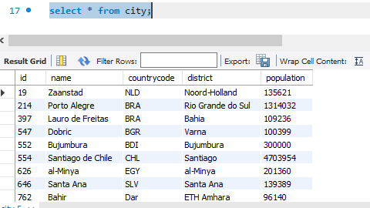

**Q4. Query all columns for a city in CITY with the ID 1661.**

**Answer:**

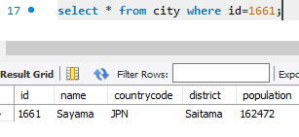

**Q5. Query all attributes of every Japanese city in the CITY table. The COUNTRYCODE for Japan is**

**JPN.**

**Answer:**

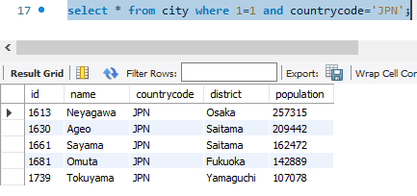

**Q6. Query the names of all the Japanese cities in the CITY table. The COUNTRYCODE for Japan is**

**JPN.**

**Answer:**

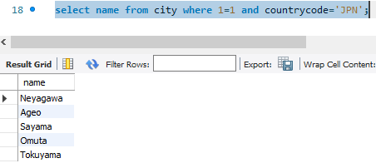

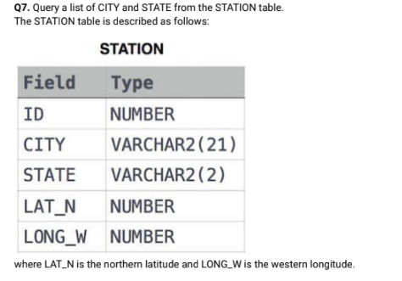

**Answer:**

create table station

(

id integer,

city varchar(21),

state varchar(2),

lat_n integer,

long_w integer

);

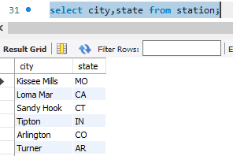

**Q8. Query a list of CITY names from STATION for cities that have an even ID number. Print the results**

**in any order, but exclude duplicates from the answer.**

**Answer:**

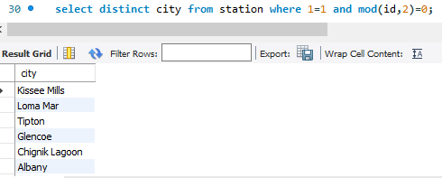

**Q9. Find the difference between the total number of CITY entries in the table and the number of**

**distinct CITY entries in the table.**

**Answer:**

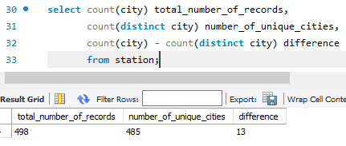

**Q10. Query the two cities in STATION with the shortest and longest CITY names, as well as their**

**respective lengths (i.e.: number of characters in the name). If there is more than one smallest or**

**largest city, choose the one that comes first when ordered alphabetically.**

**Answer:**

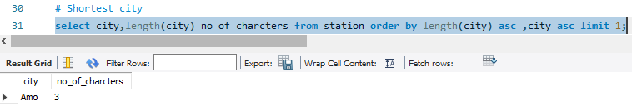

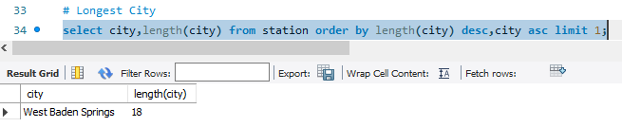

**Q11. Query the list of CITY names starting with vowels (i.e., a, e, i, o, or u) from STATION. Your result**

**cannot contain duplicates.**

**Answer:**

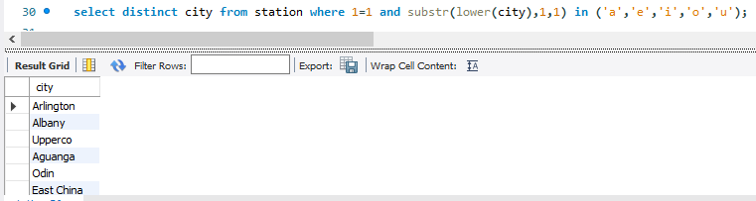

**Q12. Query the list of CITY names ending with vowels (a, e, i, o, u) from STATION. Your result cannot**

**contain duplicates.**

**Answer:**

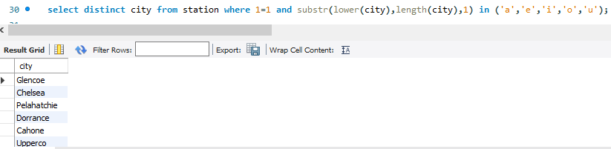

**Q13. Query the list of CITY names from STATION that do not start with vowels. Your result cannot**

**contain duplicates.**

**Answer:**

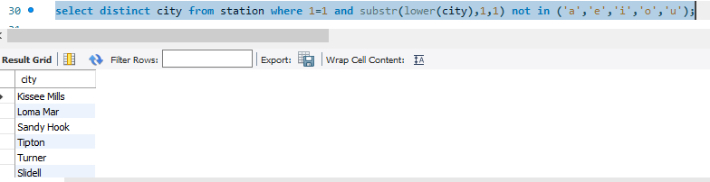

**Q14. Query the list of CITY names from STATION that do not end with vowels. Your result cannot**

**contain duplicates.**

**Answer:**

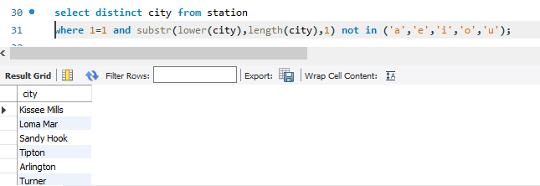

**Q15. Query the list of CITY names from STATION that either do not start with vowels or do not end**

**with vowels. Your result cannot contain duplicates.**

**Answer:**

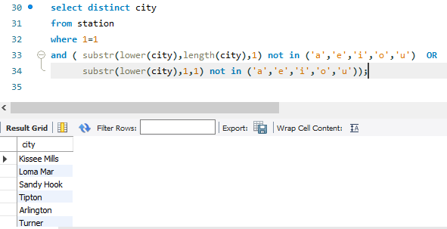

**Q16. Query the list of CITY names from STATION that do not start with vowels and do not end with**

**vowels. Your result cannot contain duplicates.**

**Answer:**

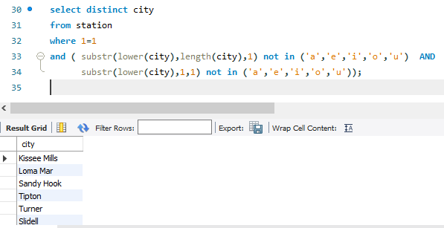

# Q17.

Table: Product

|  |  |
| --- | --- |
| Column Name | Type |
| product_id | int |
| product_name | varchar |
| unit_price | int |

product_id is the primary key of this table.

Each row of this table indicates the name and the price of each product. Table: Sales

|  |  |
| --- | --- |
| Column Name | Type |
| seller_id | int |
| product_id | int |
| buyer_id | int |
| sale_date | date |
| quantity | int |
| price | int |

This table has no primary key, it can have repeated rows.

product_id is a foreign key to the Product table.

Each row of this table contains some information about one sale.

Write an SQL query that reports the products that were only sold in the ﬁrst quarter of 2019. That is, between 2019-01-01 and 2019-03-31 inclusive.

Return the result table in any order.

The query result format is in the following example.

Input:

Product table:

|  |  |  |
| --- | --- | --- |
| product_id | product_name | unit_price |
| 1 | S8 | 1000 |
| 2 | G4 | 800 |
| 3 | iPhone | 1400 |

Sales table:

|  |  |  |  |  |  |
| --- | --- | --- | --- | --- | --- |
| seller_id | product_id | buyer_id | sale_date | quantity | price |
| 1 | 1 | 1 | 2019-01-21 | 2 | 2000 |
| 1 | 2 | 2 | 2019-02-17 | 1 | 800 |
| 2 | 2 | 3 | 2019-06-02 | 1 | 800 |
| 3 | 3 | 4 | 2019-05-13 | 2 | 2800 |

Output:

|  |  |
| --- | --- |
| product_id | product_name |
| 1 | S8 |

Explanation:

The product with id 1 was only sold in the spring of 2019.

The product with id 2 was sold in the spring of 2019 but was also sold after the spring of 2019. The product with id 3 was sold after spring 2019.

We return only product 1 as it is the product that was only sold in the spring of 2019.

**Answer:**

create table product

(

product_id int,

product_name varchar(30),

unit_price int,

primary key (product_id)

);

create table sales

(

seller_id int,

product_id int,

buyer_id int,

sale_date date,

quantity int,

price int,

foreign key (product_id) references product(product_id)

);

insert into product (product_id,product_name,unit_price) values

(1,'S8',1000),

(2,'G4',800),

(3,'iPhone',1400);

insert into sales (seller_id,product_id,buyer_id,sale_date,quantity,price)

values (1,1,1,'2019-01-21',2,2000),

(1,2,2,'2019-02-17',1,800),

(2,2,3,'2019-06-02',1,800),

(3,3,4,'2019-05-13',2,2800);

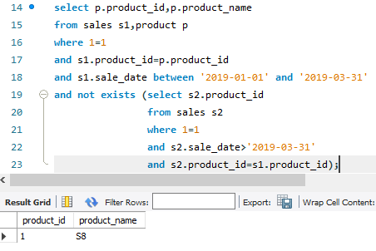

# Q18.

Table: Views

|  |  |
| --- | --- |
| Column Name | Type |
| article_id | int |
| author_id | int |
| viewer_id | int |
| view_date | date |

There is no primary key for this table, it may have duplicate rows.

Each row of this table indicates that some viewer viewed an article (written by some author) on some date.

Note that equal author_id and viewer_id indicate the same person.

Write an SQL query to ﬁnd all the authors that viewed at least one of their own articles. Return the result table sorted by id in ascending order.

The query result format is in the following example.

Input: Views table:

|  |  |  |  |
| --- | --- | --- | --- |
| article_id | author_id | viewer_id | view_date |
| 1 | 3 | 5 | 2019-08-01 |
| 1 | 3 | 6 | 2019-08-02 |
| 2 | 7 | 7 | 2019-08-01 |
| 2 | 7 | 6 | 2019-08-02 |
| 4 | 7 | 1 | 2019-07-22 |
| 3 | 4 | 4 | 2019-07-21 |
| 3 | 4 | 4 | 2019-07-21 |

Output:

|  |
| --- |
| id |
| 4 |
| 7 |

**Answer:**

create table views

(

article_id int,

author_id int,

viewer_id int,

view_date date

);

insert into views (article_id,author_id,viewer_id,view_date) values

(1,3,5,'2019-08-01'),

(1,3,6,'2019-08-02'),

(2,7,7,'2019-08-01'),

(2,7,6,'2019-08-02'),

(4,7,1,'2019-07-22'),

(3,4,4,'2019-07-21'),

(3,4,4,'2019-07-21');

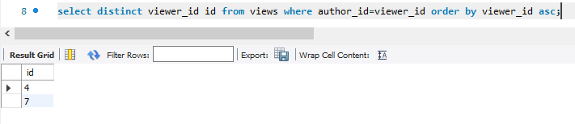

# Q19.

Table: Delivery

|  |  |
| --- | --- |
| Column Name | Type |
| delivery_id | int |
| customer_id | int |
| order_date | date |
| customer_pref_delivery_date | date |

delivery_id is the primary key of this table.

The table holds information about food delivery to customers that make orders at some date and specify a preferred delivery date (on the same order date or after it).

If the customer's preferred delivery date is the same as the order date, then the order is called immediately; otherwise, it is called scheduled.

Write an SQL query to ﬁnd the percentage of immediate orders in the table, rounded to 2 decimal places.

The query result format is in the following example.

Input: Delivery table:

|  |  |  |  |
| --- | --- | --- | --- |
| delivery_id | customer_id | order_date | customer_pref_ delivery_date |
| 1 | 1 | 2019-08-01 | 2019-08-02 |
| 2 | 5 | 2019-08-02 | 2019-08-02 |
| 3 | 1 | 2019-08-11 | 2019-08-11 |
| 4 | 3 | 2019-08-24 | 2019-08-26 |
| 5 | 4 | 2019-08-21 | 2019-08-22 |
| 6 | 2 | 2019-08-11 | 2019-08-13 |

Output:

33.33

immediate_percentage

Explanation: The orders with delivery id 2 and 3 are immediate while the others are scheduled.

**Answer:**

create table delivery

(

delivery_id int,

customer_id int,

order_date date,

customer_pref_delivery_date date,

primary key (delivery_id)

);

insert into delivery (delivery_id,customer_id,order_date,customer_pref_delivery_date) values

(1,1,'2019-08-01','2019-08-02'),

(2,5,'2019-08-02','2019-08-02'),

(3,1,'2019-08-11','2019-08-11'),

(4,3,'2019-08-24','2019-08-26'),

(5,4,'2019-08-21','2019-08-22'),

(6,2,'2019-08-11','2019-08-13');

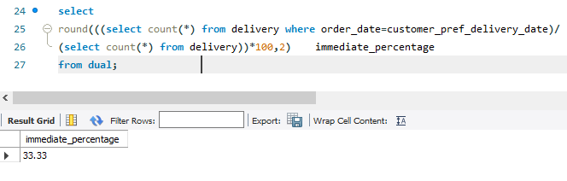

# Q20.

Table: Ads

|  |  |
| --- | --- |
| Column Name | Type |
| ad_id | int |
| user_id | int |
| action | enum |

(ad_id, user_id) is the primary key for this table.

Each row of this table contains the ID of an Ad, the ID of a user, and the action taken by this user regarding this Ad.

The action column is an ENUM type of ('Clicked', 'Viewed', 'Ignored').

A company is running Ads and wants to calculate the performance of each Ad. Performance of the Ad is measured using Click-Through Rate (CTR) where:



Write an SQL query to ﬁnd the ctr of each Ad. Round ctr to two decimal points.

Return the result table ordered by ctr in descending order and by ad_id in ascending order in case of a tie.

The query result format is in the following example.

Input:

Ads table:

|  |  |  |
| --- | --- | --- |
| ad_id | user_id | action |
| 1 | 1 | Clicked |
| 2 | 2 | Clicked |
| 3 | 3 | Viewed |
| 5 | 5 | Ignored |
| 1 | 7 | Ignored |
| 2 | 7 | Viewed |
| 3 | 5 | Clicked |
| 1 | 4 | Viewed |
| 2 | 11 | Viewed |
| 1 | 2 | Clicked |

Output:

|  |  |
| --- | --- |
| ad_id | ctr |
| 1 | 66.67 |
| 3 | 50 |
| 2 | 33.33 |
| 5 | 0 |

Explanation:

for ad_id = 1, ctr = (2/(2+1)) * 100 = 66.67 for ad_id = 2, ctr = (1/(1+2)) * 100 = 33.33 for ad_id = 3, ctr = (1/(1+1)) * 100 = 50.00

for ad_id = 5, ctr = 0.00, Note that ad_id = 5 has no clicks or views. Note that we do not care about Ignored Ads.

**Answer:**

create table ads

(

ad_id int,

user_id int,

action enum ('Clicked','Viewed','Ignored'),

primary key (ad_id,user_id)

);

insert into ads (ad_id,user_id,action) values

(1,1,'Clicked'),

(2,2,'Clicked'),

(3,3,'Viewed'),

(5,5,'Ignored'),

(1,7,'Ignored'),

(2,7,'Viewed'),

(3,5,'Clicked'),

(1,4,'Viewed'),

(2,11,'Viewed'),

(1,2,'Clicked');

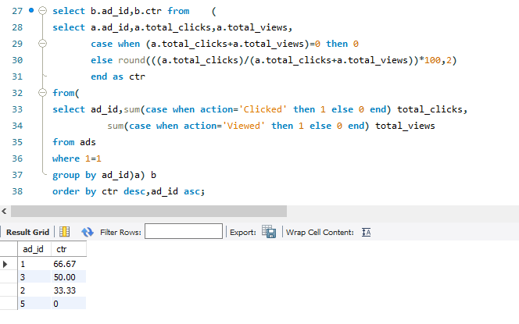

# Q21.

Table: Employee

|  |  |
| --- | --- |
| Column Name | Type |
| employee_id | int |
| team_id | int |

employee_id is the primary key for this table.

Each row of this table contains the ID of each employee and their respective team.

Write an SQL query to ﬁnd the team size of each of the employees. Return result table in any order.

The query result format is in the following example.

Input:

Employee Table:

|  |  |
| --- | --- |
| employee_id | team_id |
| 1 | 8 |
| 2 | 8 |
| 3 | 8 |
| 4 | 7 |
| 5 | 9 |
| 6 | 9 |

Output:

|  |  |
| --- | --- |
| employee_id | team_size |
| 1 | 3 |
| 2 | 3 |
| 3 | 3 |
| 4 | 1 |
| 5 | 2 |
| 6 | 2 |

Explanation:

Employees with Id 1,2,3 are part of a team with team_id = 8. An employee with Id 4 is part of a team with team_id = 7.

Employees with Id 5,6 are part of a team with team_id = 9.

**Answer:**

create table employee

(

employee_id int,

team_id int,

primary key (employee_id)

);

insert into employee (employee_id,team_id) values

(1,8),

(2,8),

(3,8),

(4,7),

(5,9),

(6,9);

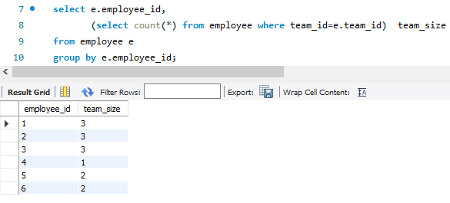

# Q22.

Table: Countries

|  |  |
| --- | --- |
| Column Name | Type |
| country_id | int |
| country_name | varchar |

country_id is the primary key for this table.

Each row of this table contains the ID and the name of one country.

Table: Weather

|  |  |
| --- | --- |
| Column Name | Type |
| country_id | int |
| weather_state | int |
| day | date |

(country_id, day) is the primary key for this table.

Each row of this table indicates the weather state in a country for one day.

Write an SQL query to ﬁnd the type of weather in each country for November 2019. The type of weather is:

* Cold if the average weather_state is less than or equal 15,
* Hot if the average weather_state is greater than or equal to 25, and
* Warm otherwise. Return result table in any order.

The query result format is in the following example.

Input: Countries table:

|  |  |
| --- | --- |
| country_id | country_name |
| 2 | USA |
| 3 | Australia |
| 7 | Peru |
| 5 | China |
| 8 | Morocco |
| 9 | Spain |

Weather table:

|  |  |  |
| --- | --- | --- |
| country_id | weather_state | day |
| 2 | 15 | 2019-11-01 |
| 2 | 12 | 2019-10-28 |

|  |  |  |
| --- | --- | --- |
| 2 | 12 | 2019-10-27 |
| 3 | -2 | 2019-11-10 |
| 3 | 0 | 2019-11-11 |
| 3 | 3 | 2019-11-12 |
| 5 | 16 | 2019-11-07 |
| 5 | 18 | 2019-11-09 |
| 5 | 21 | 2019-11-23 |
| 7 | 25 | 2019-11-28 |
| 7 | 22 | 2019-12-01 |
| 7 | 20 | 2019-12-02 |
| 8 | 25 | 2019-11-05 |
| 8 | 27 | 2019-11-15 |
| 8 | 31 | 2019-11-25 |
| 9 | 7 | 2019-10-23 |
| 9 | 3 | 2019-12-23 |

Output:

|  |  |
| --- | --- |
| country_name | weather_type |
| USA | Cold |
| Australia | Cold |
| Peru | Hot |
| Morocco | Hot |
| China | Warm |

Explanation:

Average weather_state in the USA in November is (15) / 1 = 15 so the weather type is Cold.

Average weather_state in Australia in November is (-2 + 0 + 3) / 3 = 0.333 so the weather type is Cold. Average weather_state in Peru in November is (25) / 1 = 25 so the weather type is Hot.

The average weather_state in China in November is (16 + 18 + 21) / 3 = 18.333 so the weather type is warm.

Average weather_state in Morocco in November is (25 + 27 + 31) / 3 = 27.667 so the weather type is Hot.

We know nothing about the average weather_state in Spain in November so we do not include it in the result table.

**Answer:**

create table countries

(

country_id int,

country_name varchar(30),

primary key (country_id)

);

create table weather

(

country_id int,

weather_state int,

day date,

primary key (country_id,day)

);

insert into countries (country_id,country_name) values

(2,'USA'),

(3,'Australia'),

(7,'Peru'),

(5,'China'),

(8,'Morocco'),

(9,'Spain');

insert into weather(country_id,weather_state,day) values

(2,15,'2019-11-01'),

(2,12,'2019-10-28'),

(2,12,'2019-10-27'),

(3,-2,'2019-11-10'),

(3,0,'2019-11-11'),

(3,3,'2019-11-12'),

(5,16,'2019-11-07'),

(5,18,'2019-11-09'),

(5,21,'2019-11-23'),

(7,25,'2019-11-28'),

(7,22,'2019-12-01'),

(7,20,'2019-12-02'),

(8,25,'2019-11-05'),

(8,27,'2019-11-15'),

(8,31,'2019-11-25'),

(9,7,'2019-10-23'),

(9,3,'2019-12-23');

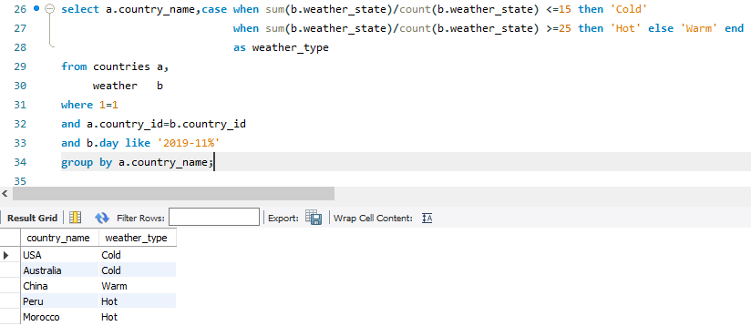

# Q23.

Table: Prices

|  |  |
| --- | --- |
| Column Name | Type |
| product_id | int |
| start_date | date |
| end_date | date |
| price | int |

(product_id, start_date, end_date) is the primary key for this table.

Each row of this table indicates the price of the product_id in the period from start_date to end_date. For each product_id there will be no two overlapping periods. That means there will be no two intersecting periods for the same product_id.

Table: UnitsSold

|  |  |
| --- | --- |
| Column Name | Type |
| product_id | int |
| purchase_date | date |
| units | int |

There is no primary key for this table, it may contain duplicates.

Each row of this table indicates the date, units, and product_id of each product sold.

Write an SQL query to ﬁnd the average selling price for each product. average_price should be rounded to 2 decimal places.

Return the result table in any order.

The query result format is in the following example.

Input: Prices table:

|  |  |  |  |
| --- | --- | --- | --- |
| product_id | start_date | end_date | price |
| 1 | 2019-02-17 | 2019-02-28 | 5 |
| 1 | 2019-03-01 | 2019-03-22 | 20 |
| 2 | 2019-02-01 | 2019-02-20 | 15 |
| 2 | 2019-02-21 | 2019-03-31 | 30 |

UnitsSold table:

|  |  |  |
| --- | --- | --- |
| product_id | purchase_date | units |
| 1 | 2019-02-25 | 100 |
| 1 | 2019-03-01 | 15 |
| 2 | 2019-02-10 | 200 |
| 2 | 2019-03-22 | 30 |

Output:

|  |  |
| --- | --- |
| product_id | average_price |
| 1 | 6.96 |
| 2 | 16.96 |

Explanation:

Average selling price = Total Price of Product / Number of products sold. Average selling price for product 1 = ((100 * 5) + (15 * 20)) / 115 = 6.96

Average selling price for product 2 = ((200 * 15) + (30 * 30)) / 230 = 16.96

**Answer:**

create table prices

(

product_id int,

start_date date,

end_date date,

price int,

primary key (product_id,start_date,end_date)

);

create table unitssold

(

product_id int,

purchase_date date,

units int

);

insert into prices (product_id,start_date,end_date,price) values

(1,'2019-02-17','2019-02-28',5),

(1,'2019-03-01','2019-03-22',20),

(2,'2019-02-01','2019-02-20',15),

(2,'2019-02-21','2019-03-31',30);

insert into unitssold(product_id,purchase_date,units) values

(1,'2019-02-25',100),

(1,'2019-03-01',15),

(2,'2019-02-10',200),

(2,'2019-03-22',30);

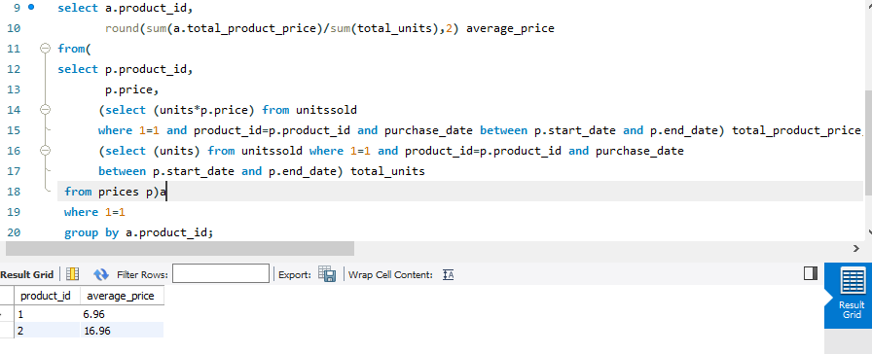

# Q24.

Table: Activity

|  |  |
| --- | --- |
| Column Name | Type |
| player_id | int |
| device_id | int |
| event_date | date |
| games_played | int |

(player_id, event_date) is the primary key of this table. This table shows the activity of players of some games.

Each row is a record of a player who logged in and played a number of games (possibly 0) before logging out on someday using some device.

Write an SQL query to report the ﬁrst login date for each player. Return the result table in any order.

The query result format is in the following example.

Input: Activity table:

|  |  |  |  |
| --- | --- | --- | --- |
| player_id | device_id | event_date | games_played |
| 1 | 2 | 2016-03-01 | 5 |
| 1 | 2 | 2016-05-02 | 6 |
| 2 | 3 | 2017-06-25 | 1 |
| 3 | 1 | 2016-03-02 | 0 |
| 3 | 4 | 2018-07-03 | 5 |

Output:

|  |  |
| --- | --- |
| player_id | ﬁrst_login |
| 1 | 2016-03-01 |
| 2 | 2017-06-25 |
| 3 | 2016-03-02 |

**Answer:**

create table activity

(

player_id int,

device_id int,

event_date date,

games_played int,

primary key (player_id,event_date)

);

insert into activity (player_id,device_id,event_date,games_played) values

(1,2,'2016-03-01',5),

(1,2,'2016-05-02',6),

(2,3,'2017-06-25',1),

(3,1,'2016-03-02',0),

(3,4,'2018-07-03',5);

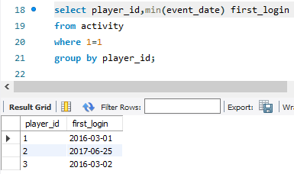

# Q25.

Table: Activity

|  |  |
| --- | --- |
| Column Name | Type |
| player_id | int |
| device_id | int |
| event_date | date |
| games_played | int |

(player_id, event_date) is the primary key of this table. This table shows the activity of players of some games.

Each row is a record of a player who logged in and played a number of games (possibly 0) before logging out on someday using some device.

Write an SQL query to report the device that is ﬁrst logged in for each player. Return the result table in any order.

The query result format is in the following example.

Input: Activity table:

|  |  |  |  |
| --- | --- | --- | --- |
| player_id | device_id | event_date | games_played |
| 1 | 2 | 2016-03-01 | 5 |
| 1 | 2 | 2016-05-02 | 6 |
| 2 | 3 | 2017-06-25 | 1 |
| 3 | 1 | 2016-03-02 | 0 |
| 3 | 4 | 2018-07-03 | 5 |

Output:

|  |  |
| --- | --- |
| player_id | device_id |
| 1 | 2 |
| 2 | 3 |
| 3 | 1 |

**Answer:**

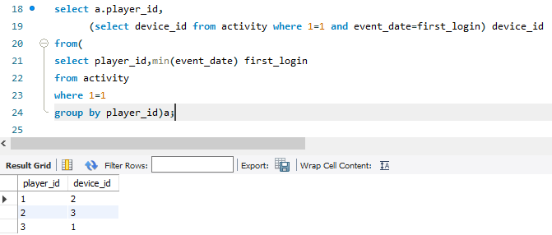

# Q26.

Table: Products

|  |  |
| --- | --- |
| Column Name | Type |
| product_id | int |
| product_name | varchar |
| product_category | varchar |

product_id is the primary key for this table.

This table contains data about the company's products.

Table: Orders

|  |  |
| --- | --- |
| Column Name | Type |
| product_id | int |
| order_date | date |
| unit | int |

There is no primary key for this table. It may have duplicate rows. product_id is a foreign key to the Products table.

unit is the number of products ordered in order_date.

Write an SQL query to get the names of products that have at least 100 units ordered in February 2020 and their amount.

Return result table in any order.

The query result format is in the following example.

Input: Products table:

|  |  |  |
| --- | --- | --- |
| product_id | product_name | product_catego ry |
| 1 | Leetcode Solutions | Book |
| 2 | Jewels of Stringology | Book |
| 3 | HP | Laptop |
| 4 | Lenovo | Laptop |
| 5 | Leetcode Kit | T-shirt |

Orders table:

|  |  |  |
| --- | --- | --- |
| product_id | order_date | unit |
| 1 | 2020-02-05 | 60 |
| 1 | 2020-02-10 | 70 |
| 2 | 2020-01-18 | 30 |
| 2 | 2020-02-11 | 80 |
| 3 | 2020-02-17 | 2 |
| 3 | 2020-02-24 | 3 |
| 4 | 2020-03-01 | 20 |
| 4 | 2020-03-04 | 30 |
| 4 | 2020-03-04 | 60 |
| 5 | 2020-02-25 | 50 |
| 5 | 2020-02-27 | 50 |
| 5 | 2020-03-01 | 50 |

Output:

|  |  |
| --- | --- |
| product_name | unit |
| Leetcode Solutions | 130 |
| Leetcode Kit | 100 |

Explanation:

Products with product_id = 1 is ordered in February a total of (60 + 70) = 130. Products with product_id = 2 is ordered in February a total of 80.

Products with product_id = 3 is ordered in February a total of (2 + 3) = 5. Products with product_id = 4 was not ordered in February 2020.

Products with product_id = 5 is ordered in February a total of (50 + 50) = 100.

**Answer:**

create table products

(

product_id int,

product_name varchar(30),

product_category varchar(30),

primary key (product_id)

);

create table orders

(

product_id int,

order_date date,

unit int,

foreign key (product_id) references products(product_id)

);

insert into products (product_id,product_name,product_category) values

(1,'Leetcode Solutions','Book'),

(2,'Jewels of Stringology','Book'),

(3,'HP','Laptop'),

(4,'Lenovo','Laptop'),

(5,'Leetcode kit','T-shirt');

insert into orders (product_id,order_date,unit) values

(1,'2020-02-05',60),

(1,'2020-02-10',70),

(2,'2020-01-18',30),

(2,'2020-02-11',80),

(3,'2020-02-17',2),

(3,'2020-02-24',3),

(4,'2020-03-01',20),

(4,'2020-03-04',30),

(4,'2020-03-04',60),

(5,'2020-02-25',50),

(5,'2020-02-27',50),

(5,'2020-03-01',50);

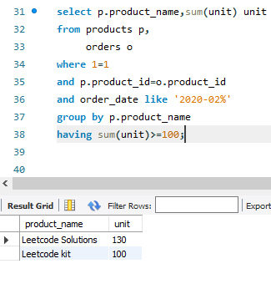

# Q27.

Table: Users

|  |  |
| --- | --- |
| Column Name | Type |
| user_id | int |
| name | varchar |
| mail | varchar |

user_id is the primary key for this table.

This table contains information of the users signed up in a website. Some emails are invalid.

Write an SQL query to ﬁnd the users who have valid emails. A valid e-mail has a preﬁx name and a domain where:

* The preﬁx name is a string that may contain letters (upper or lower case), digits, underscore '_', period '.', and/or dash '-'. The preﬁx name must start with a letter.
* The domain is '@leetcode.com'. Return the result table in any order.

The query result format is in the following example.

Input:

Users table:

|  |  |  |
| --- | --- | --- |
| user_id | name | mail |
| 1 | Winston | winston@leetc ode.com |
| 2 | Jonathan | jonathanisgreat |
| 3 | Annabelle | bella-@leetcod e.com |
| 4 | Sally | sally.come@lee tcode.com |
| 5 | Marwan | quarz#2020@le etcode.com |
| 6 | David | david69@gmail  .com |
| 7 | Shapiro | .shapo@leetco de.com |

Output:

|  |  |  |
| --- | --- | --- |
| user_id | name | mail |
| 1 | Winston | winston@leetc ode.com |
| 3 | Annabelle | bella-@leetcod e.com |
| 4 | Sally | sally.come@lee tcode.com |

Explanation:

The mail of user 2 does not have a domain.

The mail of user 5 has the # sign which is not allowed. The mail of user 6 does not have the leetcode domain. The mail of user 7 starts with a period.

**Answer:**

create table users

(

user_id int,

name varchar(30),

mail varchar(240),

primary key(user_id)

);

insert into users (user_id,name,mail) values

(1,'Winston','winston@leetcode.com'),

(2,'Jonathan','jonathanisgreat'),

(3,'Annabelle','bella-@leetcode.com'),

(4,'Sally','sally.come@leetcode.com'),

(5,'Marwan','quarz#2020@leetcode.com'),

(6,'David','david69@gmail.com'),

(7,'Shapiro','.shapo@leetcode.com');

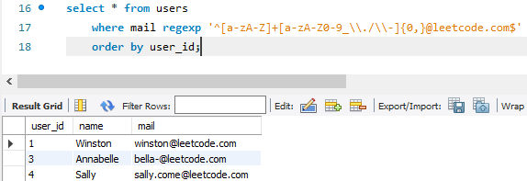

**Q28**.

Table: Customers

|  |  |
| --- | --- |
| Column Name | Type |
| customer_id | int |
| name | varchar |
| country | varchar |

customer_id is the primary key for this table.

This table contains information about the customers in the company.

Table: Product

|  |  |
| --- | --- |
| Column Name | Type |
| customer_id | int |
| name | varchar |
| country | varchar |

product_id is the primary key for this table.

This table contains information on the products in the company. price is the product cost.

Table: Orders

|  |  |
| --- | --- |
| Column Name | Type |
| order_id | int |
| customer_id | int |
| product_id | int |
| order_date | date |
| quantity | int |

order_id is the primary key for this table.

This table contains information on customer orders.

customer_id is the id of the customer who bought "quantity" products with id "product_id". Order_date is the date in format ('YYYY-MM-DD') when the order was shipped.

Write an SQL query to report the customer_id and customer_name of customers who have spent at least $100 in each month of June and July 2020.

Return the result table in any order.

The query result format is in the following example.

Input: Customers table:

|  |  |  |
| --- | --- | --- |
| customer_id | name | country |
| 1 | Winston | USA |
| 2 | Jonathan | Peru |
| 3 | Moustafa | Egypt |

Product table:

|  |  |  |
| --- | --- | --- |
| product_id | description | price |
| 10 | LC Phone | 300 |
| 20 | LC T-Shirt | 10 |
| 30 | LC Book | 45 |
| 40 | LC Keychain | 2 |

Orders table:

|  |  |  |  |  |
| --- | --- | --- | --- | --- |
| order_id | customer_id | product_id | order_date | quantity |
| 1 | 1 | 10 | 2020-06-10 | 1 |
| 2 | 1 | 20 | 2020-07-01 | 1 |
| 3 | 1 | 30 | 2020-07-08 | 2 |
| 4 | 2 | 10 | 2020-06-15 | 2 |
| 5 | 2 | 40 | 2020-07-01 | 10 |
| 6 | 3 | 20 | 2020-06-24 | 2 |
| 7 | 3 | 30 | 2020-06-25 | 2 |
| 9 | 3 | 30 | 2020-05-08 | 3 |

Output:

|  |  |
| --- | --- |
| customer_id | name |
| 1 | Winston |

Explanation:

Winston spent $300 (300 * 1) in June and $100 ( 10 * 1 + 45 * 2) in July 2020. Jonathan spent $600 (300 * 2) in June and $20 ( 2 * 10) in July 2020.

Moustafa spent $110 (10 * 2 + 45 * 2) in June and $0 in July 2020.

**Answer:**

create table customers

(

customer_id int,

name varchar(30),

country varchar(30),

primary key(customer_id)

);

create table products

(

product_id int,

description varchar(240),

price int,

primary key(product_id)

);

create table orders

(

order_id int,

customer_id int,

product_id int,

order_date date,

quantity int,

primary key(order_id)

);

insert into customers (customer_id,name,country) values

(1,'Winston','USA'),

(2,'Jonathan','Peru'),

(3,'Moustafa','Egypt');

insert into products (product_id,description,price) values

(10,'LC Phone',300),

(20,'LC T-Shirt',10),

(30,'LC Book',45),

(40,'LC Keychain',2);

insert into orders (order_id,customer_id,product_id,order_date,quantity) values

(1,1,10,'2020-06-10',1),

(2,1,20,'2020-07-01',1),

(3,1,30,'2020-07-08',2),

(4,2,10,'2020-06-15',2),

(5,2,40,'2020-07-01',10),

(6,3,20,'2020-06-24',2),

(7,3,30,'2020-06-25',2),

(9,3,30,'2020-05-08',3);

create view order_dtls_vw as

select o.customer_id,

c.name,

monthname(o.order_date) month,

year(order_date) year,

sum(o.quantity*p.price) amount

from products p,orders o,customers c

where 1=1

and p.product_id=o.product_id

and o.customer_id=c.customer_id

group by o.customer_id,c.name,monthname(o.order_date),year(order_date);

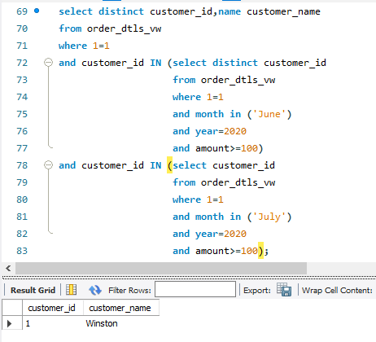

**Q29**.

Table: TVProgram

|  |  |
| --- | --- |
| Column Name | Type |
| program_date | date |
| content_id | int |
| channel | varchar |

(program_date, content_id) is the primary key for this table. This table contains information about the programs on the TV. content_id is the id of the program in some channel on the TV.

Table: Content

|  |  |
| --- | --- |
| Column Name | Type |
| content_id | varchar |
| title | varchar |
| Kids_content | enum |
| content_type | varchar |

content_id is the primary key for this table.

Kids_content is an enum that takes one of the values ('Y', 'N') where:

'Y' means content for kids, otherwise 'N' is not content for kids. content_type is the category of the content as movies, series, etc.

Write an SQL query to report the distinct titles of the kid-friendly movies streamed in June 2020. Return the result table in any order.

The query result format is in the following example.

Input: TVProgram table:

|  |  |  |
| --- | --- | --- |
| program_date | content_id | channel |
| 2020-06-10 08:00 | 1 | LC-Channel |
| 2020-05-11 12:00 | 2 | LC-Channel |
| 2020-05-12 12:00 | 3 | LC-Channel |
| 2020-05-13 14:00 | 4 | Disney Ch |
| 2020-06-18 14:00 | 4 | Disney Ch |
| 2020-07-15 16:00 | 5 | Disney Ch |

Content table:

|  |  |  |  |
| --- | --- | --- | --- |
| content_id | title | Kids_content | content_type |
| 1 | Leetcode Movie | N | Movies |
| 2 | Alg. for Kids | Y | Series |
| 3 | Database Sols | N | Series |
| 4 | Aladdin | Y | Movies |
| 5 | Cinderella | Y | Movies |

Output:

Aladdin

title

Explanation:

"Leetcode Movie" is not a content for kids. "Alg. for Kids" is not a movie.

"Database Sols" is not a movie

"Alladin" is a movie, content for kids and was streamed in June 2020. "Cinderella" was not streamed in June 2020.

**Answer:**

create table tv_program

(

program_date date,

content_id int,

channel varchar(30),

primary key (program_date,content_id)

);

create table content

(

content_id int,

title varchar(30),

kids_content enum('Y','N'),

content_type varchar(30),

primary key (content_id)

);

insert into tv_program (program_date,content_id,channel) values

('2020-06-10 08:00',1,'LC-Channel'),

('2020-05-11 12:00',2,'LC-Channel'),

('2020-05-12 12:00',3,'LC-Channel'),

('2020-05-13 14:00',4,'Disney Ch'),

('2020-06-18 14:00',4,'Disney Ch'),

('2020-07-15 16:00',5,'Disney Ch');

insert into content (content_id,title,kids_content,content_type) values

(1,'Leetcode Movie','N','Movies'),

(2,'Alg. for Kids','Y','Series'),

(3,'Database Sols','N','Series'),

(4,'Aladdin','Y','Movies'),

(5,'Cinderella','Y','Movies');

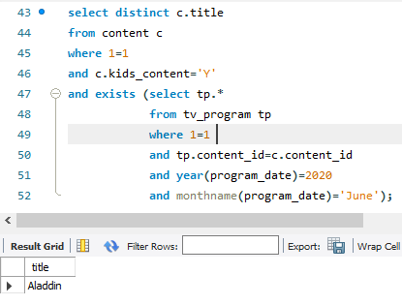

# Q30.

Table: NPV

|  |  |
| --- | --- |
| Column Name | Type |
| id | int |
| year | int |
| npv | int |

(id, year) is the primary key of this table.

The table has information about the id and the year of each inventory and the corresponding net present value.

Table: Queries

|  |  |
| --- | --- |
| Column Name | Type |
| id | int |
| year | int |

(id, year) is the primary key of this table.

The table has information about the id and the year of each inventory query.

Write an SQL query to ﬁnd the npv of each query of the Queries table. Return the result table in any order.

The query result format is in the following example.

Input: NPV table:

|  |  |  |
| --- | --- | --- |
| id | year | npv |
| 1 | 2018 | 100 |
| 7 | 2020 | 30 |
| 13 | 2019 | 40 |
| 1 | 2019 | 113 |
| 2 | 2008 | 121 |
| 3 | 2009 | 12 |
| 11 | 2020 | 99 |
| 7 | 2019 | 0 |

Queries table:

|  |  |
| --- | --- |
| id | year |
| 1 | 2019 |
| 2 | 2008 |
| 3 | 2009 |
| 7 | 2018 |
| 7 | 2019 |
| 7 | 2020 |
| 13 | 2019 |

Output:

|  |  |  |
| --- | --- | --- |
| id | year | npv |
| 1 | 2019 | 113 |
| 2 | 2008 | 121 |
| 3 | 2009 | 12 |
| 7 | 2018 | 0 |
| 7 | 2019 | 0 |
| 7 | 2020 | 30 |
| 13 | 2019 | 40 |

Explanation:

The npv value of (7, 2018) is not present in the NPV table, we consider it 0. The npv values of all other queries can be found in the NPV table.

**Answer:**

create table npv

(

id int,

year int,

npv int,

primary key (id,year)

);

create table queries

(

id int,

year int,

primary key (id,year)

);

insert into npv (id,year,npv) values

(1,2018,100),

(7,2020,30),

(13,2019,40),

(1,2019,113),

(2,2008,121),

(3,2009,12),

(11,2020,99),

(7,2019,0);

insert into queries (id,year) values

(1,2019),

(2,2008),

(3,2009),

(7,2018),

(7,2019),

(7,2020),

(13,2019);

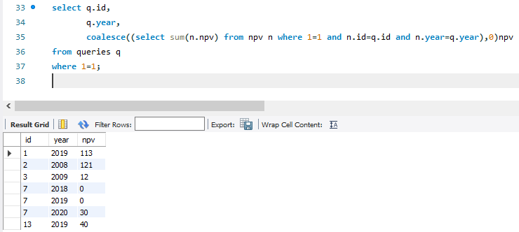

# Q30.

Table: NPV

|  |  |
| --- | --- |
| Column Name | Type |
| id | int |
| year | int |
| npv | int |

(id, year) is the primary key of this table.

The table has information about the id and the year of each inventory and the corresponding net present value.

Table: Queries

|  |  |
| --- | --- |
| Column Name | Type |
| id | int |
| year | int |

(id, year) is the primary key of this table.

The table has information about the id and the year of each inventory query.

Write an SQL query to ﬁnd the npv of each query of the Queries table. Return the result table in any order.

The query result format is in the following example.

Input: NPV table:

|  |  |  |
| --- | --- | --- |
| id | year | npv |
| 1 | 2018 | 100 |
| 7 | 2020 | 30 |
| 13 | 2019 | 40 |
| 1 | 2019 | 113 |
| 2 | 2008 | 121 |
| 3 | 2009 | 12 |
| 11 | 2020 | 99 |
| 7 | 2019 | 0 |

Queries table:

|  |  |
| --- | --- |
| id | year |
| 1 | 2019 |
| 2 | 2008 |
| 3 | 2009 |
| 7 | 2018 |
| 7 | 2019 |
| 7 | 2020 |
| 13 | 2019 |

Output:

|  |  |  |
| --- | --- | --- |
| id | year | npv |
| 1 | 2019 | 113 |
| 2 | 2008 | 121 |
| 3 | 2009 | 12 |
| 7 | 2018 | 0 |
| 7 | 2019 | 0 |
| 7 | 2020 | 30 |
| 13 | 2019 | 40 |

Explanation:

The npv value of (7, 2018) is not present in the NPV table, we consider it 0. The npv values of all other queries can be found in the NPV table.

**Answer:**

create table npv

(

id int,

year int,

npv int,

primary key (id,year)

);

create table queries

(

id int,

year int,

primary key (id,year)

);

insert into npv (id,year,npv) values

(1,2018,100),

(7,2020,30),

(13,2019,40),

(1,2019,113),

(2,2008,121),

(3,2009,12),

(11,2020,99),

(7,2019,0);

insert into queries (id,year) values

(1,2019),

(2,2008),

(3,2009),

(7,2018),

(7,2019),

(7,2020),

(13,2019);



# Q32.

Table: Employees

|  |  |
| --- | --- |
| Column Name | Type |
| id | int |
| name | varchar |

id is the primary key for this table.

Each row of this table contains the id and the name of an employee in a company.

Table: EmployeeUNI

|  |  |
| --- | --- |
| Column Name | Type |
| id | int |
| unique_id | int |

(id, unique_id) is the primary key for this table.

Each row of this table contains the id and the corresponding unique id of an employee in the company.

Write an SQL query to show the unique ID of each user, If a user does not have a unique ID replace just show null.

Return the result table in any order.

The query result format is in the following example.

Input: Employees table:

|  |  |
| --- | --- |
| id | name |
| 1 | Alice |
| 7 | Bob |
| 11 | Meir |
| 90 | Winston |
| 3 | Jonathan |

EmployeeUNI table:

|  |  |
| --- | --- |
| id | unique_id |
| 3 | 1 |
| 11 | 2 |
| 90 | 3 |

Output:

|  |  |
| --- | --- |
| unique_id | name |
| null | Alice |
| null | Bob |
| 2 | Meir |
| 3 | Winston |
| 1 | Jonathan |

Explanation:

Alice and Bob do not have a unique ID, We will show null instead. The unique ID of Meir is 2.

The unique ID of Winston is 3. The unique ID of Jonathan is 1.

**Answer:**

create table employees

(

id int,

name varchar(30),

primary key (id)

);

create table employeeuni

(

id int,

unique_id int,

primary key (id,unique_id)

);

insert into employees (id,name) values

(1,'Alice'),

(7,'Bob'),

(11,'Meir'),

(90,'Winston'),

(3,'Jonathan');

insert into employeeuni(id,unique_id) values

(3,1),

(11,2),

(90,3);

DELIMITER $$

CREATE FUNCTION `xx_get_emp_unique_id_func` (p_id integer)

RETURNS INTEGER

DETERMINISTIC

BEGIN

declare lv_unique_id integer;

select unique_id into lv_unique_id from employeeuni where 1=1 and id=p_id;

return lv_unique_id;

END$$

DELIMITER;

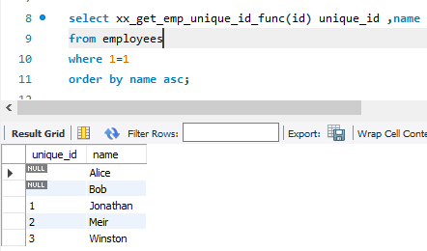

# Q33.

Table: Users

|  |  |
| --- | --- |
| Column Name | Type |
| id | int |
| name | varchar |

id is the primary key for this table. name is the name of the user.

Table: Rides

|  |  |
| --- | --- |
| Column Name | Type |
| id | int |
| user_id | int |
| distance | int |

id is the primary key for this table.

user_id is the id of the user who travelled the distance "distance".

Write an SQL query to report the distance travelled by each user.

Return the result table ordered by travelled_distance in descending order, if two or more users travelled the same distance, order them by their name in ascending order.

The query result format is in the following example.

Input: Users table:

|  |  |
| --- | --- |
| id | name |
| 1 | Alice |
| 2 | Bob |
| 3 | Alex |
| 4 | Donald |
| 7 | Lee |

|  |  |
| --- | --- |
| 13 | Jonathan |
| 19 | Elvis |

Rides table:

|  |  |  |
| --- | --- | --- |
| id | user_id | distance |
| 1 | 1 | 120 |
| 2 | 2 | 317 |
| 3 | 3 | 222 |
| 4 | 7 | 100 |
| 5 | 13 | 312 |
| 6 | 19 | 50 |
| 7 | 7 | 120 |
| 8 | 19 | 400 |
| 9 | 7 | 230 |

Output:

|  |  |
| --- | --- |
| name | travelled_distan ce |
| Elvis | 450 |
| Lee | 450 |
| Bob | 317 |
| Jonathan | 312 |
| Alex | 222 |
| Alice | 120 |
| Donald | 0 |

Explanation:

Elvis and Lee travelled 450 miles, Elvis is the top traveller as his name is alphabetically smaller than Lee.

Bob, Jonathan, Alex, and Alice have only one ride and we just order them by the total distances of the ride.

Donald did not have any rides, the distance travelled by him is 0.

**Answer:**

create table users

(

id int,

name varchar(30),

primary key (id)

);

create table rides

(

id int,

user_id int,

distance int,

primary key(id)

);

insert into users (id,name) values

(1,'Alice'),

(2,'Bob'),

(3,'Alex'),

(4,'Donald'),

(7,'Lee'),

(13,'Jonathan'),

(19,'Elvis');

insert into rides (id,user_id,distance) values

(1,1,120),

(2,2,317),

(3,3,222),

(4,7,100),

(5,13,312),

(6,19,50),

(7,7,120),

(8,19,400),

(9,7,230);

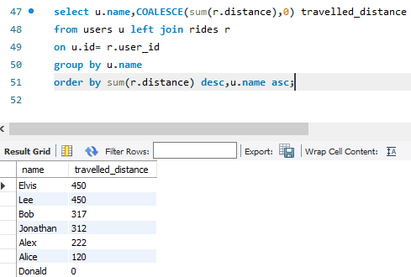

# Q34.

Table: Products

|  |  |
| --- | --- |
| Column Name | Type |
| product_id | int |
| product_name | varchar |
| product_category | varchar |

product_id is the primary key for this table.

This table contains data about the company's products.

Table: Orders

|  |  |
| --- | --- |
| Column Name | Type |
| product_id | int |
| order_date | date |
| unit | int |

There is no primary key for this table. It may have duplicate rows. product_id is a foreign key to the Products table.

unit is the number of products ordered in order_date.

Write an SQL query to get the names of products that have at least 100 units ordered in February 2020 and their amount.

Return result table in any order.

The query result format is in the following example.

Input: Products table:

|  |  |  |
| --- | --- | --- |
| product_id | product_name | product_catego ry |
| 1 | Leetcode Solutions | Book |
| 2 | Jewels of Stringology | Book |
| 3 | HP | Laptop |
| 4 | Lenovo | Laptop |
| 5 | Leetcode Kit | T-shirt |

Orders table:

|  |  |  |
| --- | --- | --- |
| product_id | order_date | unit |
| 1 | 2020-02-05 | 60 |
| 1 | 2020-02-10 | 70 |
| 2 | 2020-01-18 | 30 |
| 2 | 2020-02-11 | 80 |
| 3 | 2020-02-17 | 2 |
| 3 | 2020-02-24 | 3 |
| 4 | 2020-03-01 | 20 |
| 4 | 2020-03-04 | 30 |
| 4 | 2020-03-04 | 60 |
| 5 | 2020-02-25 | 50 |
| 5 | 2020-02-27 | 50 |
| 5 | 2020-03-01 | 50 |

Output:

|  |  |
| --- | --- |
| product_name | unit |
| Leetcode Solutions | 130 |
| Leetcode Kit | 100 |

Explanation:

Products with product_id = 1 is ordered in February a total of (60 + 70) = 130. Products with product_id = 2 is ordered in February a total of 80.

Products with product_id = 3 is ordered in February a total of (2 + 3) = 5. Products with product_id = 4 was not ordered in February 2020.

Products with product_id = 5 is ordered in February a total of (50 + 50) = 100.

**Answer:**

create table products

(

product_id int,

product_name varchar(30),

product_category varchar(30),

primary key (product_id)

);

create table orders

(

product_id int,

order_date date,

unit int,

foreign key (product_id) references products(product_id)

);

insert into products (product_id,product_name,product_category) values

(1,'Leetcode Solutions','Book'),

(2,'Jewels of Stringology','Book'),

(3,'HP','Laptop'),

(4,'Lenovo','Laptop'),

(5,'Leetcode kit','T-shirt');

insert into orders (product_id,order_date,unit) values

(1,'2020-02-05',60),

(1,'2020-02-10',70),

(2,'2020-01-18',30),

(2,'2020-02-11',80),

(3,'2020-02-17',2),

(3,'2020-02-24',3),

(4,'2020-03-01',20),

(4,'2020-03-04',30),

(4,'2020-03-04',60),

(5,'2020-02-25',50),

(5,'2020-02-27',50),

(5,'2020-03-01',50);



# Q35.

Table: Movies

|  |  |
| --- | --- |
| Column Name | Type |
| movie_id | int |
| title | varchar |

movie_id is the primary key for this table. The title is the name of the movie.

Table: Users

|  |  |
| --- | --- |
| Column Name | Type |
| user_id | int |
| name | varchar |

user_id is the primary key for this table.

Table: MovieRating

|  |  |
| --- | --- |
| Column Name | Type |
| movie_id | int |
| user_id | int |
| rating | int |
| created_at | date |

(movie_id, user_id) is the primary key for this table.

This table contains the rating of a movie by a user in their review. created_at is the user's review date.

Write an SQL query to:

* Find the name of the user who has rated the greatest number of movies. In case of a tie, return the lexicographically smaller user name.
* Find the movie name with the highest average rating in February 2020. In case of a tie, return the lexicographically smaller movie name.

The query result format is in the following example.

Input:

Movies table:

|  |  |
| --- | --- |
| movie_id | title |
| 1 | Avengers |
| 2 | Frozen 2 |
| 3 | Joker |

Users table:

|  |  |
| --- | --- |
| user_id | name |
| 1 | Daniel |
| 2 | Monica |
| 3 | Maria |
| 4 | James |

MovieRating table:

|  |  |  |  |
| --- | --- | --- | --- |
| movie_id | user_id | rating | created_at |
| 1 | 1 | 3 | 2020-01-12 |
| 1 | 2 | 4 | 2020-02-11 |
| 1 | 3 | 2 | 2020-02-12 |
| 1 | 4 | 1 | 2020-01-01 |
| 2 | 1 | 5 | 2020-02-17 |
| 2 | 2 | 2 | 2020-02-01 |
| 2 | 3 | 2 | 2020-03-01 |
| 3 | 1 | 3 | 2020-02-22 |
| 3 | 2 | 4 | 2020-02-25 |

Output:

|  |
| --- |
| results |
| Daniel |
| Frozen 2 |

**Answer:**

create table movies

(

movie_id int,

title varchar(30),

primary key (movie_id)

);

create table users

(

user_id int,

name varchar(30),

primary key (user_id)

);

create table movierating

(

movie_id int,

user_id int,

rating int,

created_at date,

primary key (movie_id,user_id)

);

insert into movies (movie_id,title) values

(1,'Avengers'),

(2,'Frozen 2'),

(3,'Joker');

insert into users (user_id,name) values

(1,'Daniel'),

(2,'Monica'),

(3,'Maria'),

(4,'James');

insert into movierating (movie_id,user_id,rating,created_at) values

(1,1,3,'2020-01-12'),

(1,2,4,'2020-02-11'),

(1,3,2,'2020-02-12'),

(1,4,1,'2020-01-01'),

(2,1,5,'2020-02-17'),

(2,2,2,'2020-02-01'),

(2,3,2,'2020-03-01'),

(3,1,3,'2020-02-22'),

(3,2,4,'2020-02-25');

select a.user_name results

from(

select u.user_id,u.name user_name,count(rating)

from movierating mr,users u

where 1=1

and mr.user_id=u.user_id

group by u.user_id,u.name

order by count(rating) desc,u.name asc limit 1)a

where 1=1

union

select a.title results

from(

select r.movie_id,m.title,avg(r.rating)

from movies m,movierating r

where 1=1

and m.movie_id=r.movie_id

and year(r.created_at)=2020

and month(r.created_at)=2

group by r.movie_id,m.title

order by avg(r.rating) desc,title asc limit 1) a

where 1=1

;

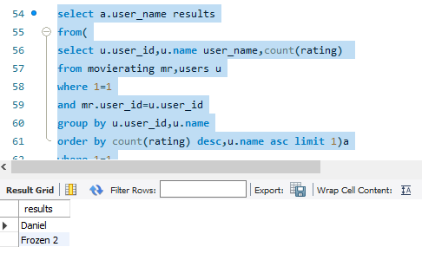

# Q36.

Table: Users

|  |  |
| --- | --- |
| Column Name | Type |
| id | int |
| name | varchar |

id is the primary key for this table. name is the name of the user.

Table: Rides

|  |  |
| --- | --- |
| Column Name | Type |
| id | int |
| user_id | int |
| distance | int |

id is the primary key for this table.

user_id is the id of the user who travelled the distance "distance".

Write an SQL query to report the distance travelled by each user.

Return the result table ordered by travelled_distance in descending order, if two or more users travelled the same distance, order them by their name in ascending order.

The query result format is in the following example.

Input: Users table:

|  |  |
| --- | --- |
| id | name |
| 1 | Alice |
| 2 | Bob |
| 3 | Alex |
| 4 | Donald |
| 7 | Lee |

|  |  |
| --- | --- |
| 13 | Jonathan |
| 19 | Elvis |

Rides table:

|  |  |  |
| --- | --- | --- |
| id | user_id | distance |
| 1 | 1 | 120 |
| 2 | 2 | 317 |
| 3 | 3 | 222 |
| 4 | 7 | 100 |
| 5 | 13 | 312 |
| 6 | 19 | 50 |
| 7 | 7 | 120 |
| 8 | 19 | 400 |
| 9 | 7 | 230 |

Output:

|  |  |
| --- | --- |
| name | travelled_distan ce |
| Elvis | 450 |
| Lee | 450 |
| Bob | 317 |
| Jonathan | 312 |
| Alex | 222 |
| Alice | 120 |
| Donald | 0 |

Explanation:

Elvis and Lee travelled 450 miles, Elvis is the top traveller as his name is alphabetically smaller than Lee.

Bob, Jonathan, Alex, and Alice have only one ride and we just order them by the total distances of the ride.

Donald did not have any rides, the distance travelled by him is 0.

**Answer:**

create table users

(

id int,

name varchar(30),

primary key (id)

);

create table rides

(

id int,

user_id int,

distance int,

primary key(id)

);

insert into users (id,name) values

(1,'Alice'),

(2,'Bob'),

(3,'Alex'),

(4,'Donald'),

(7,'Lee'),

(13,'Jonathan'),

(19,'Elvis');

insert into rides (id,user_id,distance) values

(1,1,120),

(2,2,317),

(3,3,222),

(4,7,100),

(5,13,312),

(6,19,50),

(7,7,120),

(8,19,400),

(9,7,230);



# Q37.

Table: Employees

|  |  |
| --- | --- |
| Column Name | Type |
| id | int |
| name | varchar |

id is the primary key for this table.

Each row of this table contains the id and the name of an employee in a company.

Table: EmployeeUNI

|  |  |
| --- | --- |
| Column Name | Type |
| id | int |
| unique_id | int |

(id, unique_id) is the primary key for this table.

Each row of this table contains the id and the corresponding unique id of an employee in the company.

Write an SQL query to show the unique ID of each user, If a user does not have a unique ID replace just show null.

Return the result table in any order.

The query result format is in the following example.

Input: Employees table:

|  |  |
| --- | --- |
| id | name |
| 1 | Alice |
| 7 | Bob |
| 11 | Meir |
| 90 | Winston |
| 3 | Jonathan |

EmployeeUNI table:

|  |  |
| --- | --- |
| id | unique_id |
| 3 | 1 |
| 11 | 2 |
| 90 | 3 |

Output:

|  |  |
| --- | --- |
| unique_id | name |
| null | Alice |
| null | Bob |
| 2 | Meir |
| 3 | Winston |
| 1 | Jonathan |

Explanation:

Alice and Bob do not have a unique ID, We will show null instead. The unique ID of Meir is 2.

The unique ID of Winston is 3. The unique ID of Jonathan is 1.

**Answer:**

create table employees

(

id int,

name varchar(30),

primary key (id)

);

create table employeeuni

(

id int,

unique_id int,

primary key (id,unique_id)

);

insert into employees (id,name) values

(1,'Alice'),

(7,'Bob'),

(11,'Meir'),

(90,'Winston'),

(3,'Jonathan');

insert into employeeuni(id,unique_id) values

(3,1),

(11,2),

(90,3);

DELIMITER $$

CREATE FUNCTION `xx_get_emp_unique_id_func` (p_id integer)

RETURNS INTEGER

DETERMINISTIC

BEGIN

declare lv_unique_id integer;

select unique_id into lv_unique_id from employeeuni where 1=1 and id=p_id;

return lv_unique_id;

END$$

DELIMITER;



# Q38.

Table: Departments

|  |  |
| --- | --- |
| Column Name | Type |
| id | int |
| name | varchar |

id is the primary key of this table.

The table has information about the id of each department of a university.

Table: Students

|  |  |
| --- | --- |
| Column Name | Type |
| id | int |
| name | varchar |
| department_id | int |

id is the primary key of this table.

The table has information about the id of each student at a university and the id of the department he/she studies at.

Write an SQL query to ﬁnd the id and the name of all students who are enrolled in departments that no longer exist.

Return the result table in any order.

The query result format is in the following example.

Input: Departments table:

|  |  |
| --- | --- |
| id | name |
| 1 | Electrical Engineering |
| 7 | Computer Engineering |
| 13 | Business Administration |

Students table:

|  |  |  |
| --- | --- | --- |
| id | name | department_id |
| 23 | Alice | 1 |
| 1 | Bob | 7 |
| 5 | Jennifer | 13 |
| 2 | John | 14 |
| 4 | Jasmine | 77 |
| 3 | Steve | 74 |
| 6 | Luis | 1 |
| 8 | Jonathan | 7 |
| 7 | Daiana | 33 |
| 11 | Madelynn | 1 |

Output:

|  |  |
| --- | --- |
| id | name |
| 2 | John |
| 7 | Daiana |
| 4 | Jasmine |
| 3 | Steve |

Explanation:

John, Daiana, Steve, and Jasmine are enrolled in departments 14, 33, 74, and 77 respectively. Department 14, 33, 74, and 77 do not exist in the Departments table.

**Answer:**

create table departments

(

id int,

name varchar(30),

primary key(id)

);

create table students

(

id int,

name varchar(30),

department_id int,

primary key (id)

);

insert into departments(id,name) values

(1,'Electrical Engineering'),

(7,'Computer Engineering'),

(13,'Business Administration');

insert into students (id,name,department_id) values

(23,'Alice',1),

(1,'Bob',7),

(5,'Jennifer',13),

(2,'John',14),

(4,'Jasmine',77),

(3,'Steve',74),

(6,'Luis',1),

(8,'Jonathan',7),

(7,'Daiana',33),

(11,'Madelynn',1);

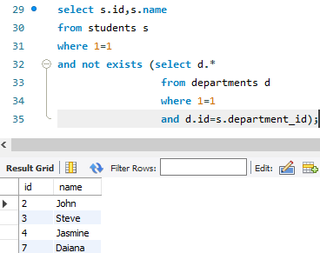

# Q39.

Table: Calls

|  |  |
| --- | --- |
| Column Name | Type |
| from_id | int |
| to_id | int |
| duration | int |

This table does not have a primary key, it may contain duplicates.

This table contains the duration of a phone call between from_id and to_id. from_id != to_id

Write an SQL query to report the number of calls and the total call duration between each pair of distinct persons (person1, person2) where person1 < person2.

Return the result table in any order.

The query result format is in the following example.

Input: Calls table:

|  |  |  |
| --- | --- | --- |
| from_id | to_id | duration |
| 1 | 2 | 59 |
| 2 | 1 | 11 |
| 1 | 3 | 20 |
| 3 | 4 | 100 |
| 3 | 4 | 200 |
| 3 | 4 | 200 |
| 4 | 3 | 499 |

Output:

|  |  |  |  |
| --- | --- | --- | --- |
| person1 | person2 | call_count | total_duration |
| 1 | 2 | 2 | 70 |
| 1 | 3 | 1 | 20 |
| 3 | 4 | 4 | 999 |

Explanation:

Users 1 and 2 had 2 calls and the total duration is 70 (59 + 11).

Users 1 and 3 had 1 call and the total duration is 20.

Users 3 and 4 had 4 calls and the total duration is 999 (100 + 200 + 200 + 499).

**Answer:**

create table calls

(

from_id int,

to_id int,

duration int

);

insert into calls (from_id,to_id,duration) values

(1,2,59),

(2,1,11),

(1,3,20),

(3,4,100),

(3,4,200),

(3,4,200),

(4,3,499);

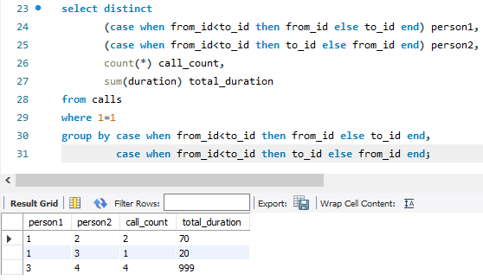

# Q40.

Table: Prices

|  |  |
| --- | --- |
| Column Name | Type |
| product_id | int |
| start_date | date |
| end_date | date |
| price | int |

(product_id, start_date, end_date) is the primary key for this table.

Each row of this table indicates the price of the product_id in the period from start_date to end_date. For each product_id there will be no two overlapping periods. That means there will be no two intersecting periods for the same product_id.

Table: UnitsSold

|  |  |
| --- | --- |
| Column Name | Type |
| product_id | int |
| purchase_date | date |
| units | int |

There is no primary key for this table, it may contain duplicates.

Each row of this table indicates the date, units, and product_id of each product sold.

Write an SQL query to ﬁnd the average selling price for each product. average_price should be rounded to 2 decimal places.

Return the result table in any order.

The query result format is in the following example.

Input: Prices table:

|  |  |  |  |
| --- | --- | --- | --- |
| product_id | start_date | end_date | price |
| 1 | 2019-02-17 | 2019-02-28 | 5 |
| 1 | 2019-03-01 | 2019-03-22 | 20 |
| 2 | 2019-02-01 | 2019-02-20 | 15 |
| 2 | 2019-02-21 | 2019-03-31 | 30 |

UnitsSold table:

|  |  |  |
| --- | --- | --- |
| product_id | purchase_date | units |
| 1 | 2019-02-25 | 100 |
| 1 | 2019-03-01 | 15 |
| 2 | 2019-02-10 | 200 |
| 2 | 2019-03-22 | 30 |

Output:

|  |  |
| --- | --- |
| product_id | average_price |
| 1 | 6.96 |
| 2 | 16.96 |

Explanation:

Average selling price = Total Price of Product / Number of products sold. Average selling price for product 1 = ((100 * 5) + (15 * 20)) / 115 = 6.96

Average selling price for product 2 = ((200 * 15) + (30 * 30)) / 230 = 16.96

**Answer:**

create table prices

(

product_id int,

start_date date,

end_date date,

price int,

primary key (product_id,start_date,end_date)

);

create table unitssold

(

product_id int,

purchase_date date,

units int

);

insert into prices (product_id,start_date,end_date,price) values

(1,'2019-02-17','2019-02-28',5),

(1,'2019-03-01','2019-03-22',20),

(2,'2019-02-01','2019-02-20',15),

(2,'2019-02-21','2019-03-31',30);

insert into unitssold(product_id,purchase_date,units) values

(1,'2019-02-25',100),

(1,'2019-03-01',15),

(2,'2019-02-10',200),

(2,'2019-03-22',30);



# Q41.

Table: Warehouse

|  |  |
| --- | --- |
| Column Name | Type |
| name | varchar |
| product_id | int |
| units | int |

(name, product_id) is the primary key for this table.

Each row of this table contains the information of the products in each warehouse.

Table: Products

|  |  |
| --- | --- |
| Column Name | Type |
| product_id | int |
| product_name | varchar |
| Width | int |
| Length | int |
| Height | int |

product_id is the primary key for this table.

Each row of this table contains information about the product dimensions (Width, Length, and Height) in feets of each product.

Write an SQL query to report the number of cubic feet of volume the inventory occupies in each warehouse.

Return the result table in any order.

The query result format is in the following example.

Input: Warehouse table:

|  |  |  |
| --- | --- | --- |
| name | product_id | units |
| LCHouse1 | 1 | 1 |
| LCHouse1 | 2 | 10 |
| LCHouse1 | 3 | 5 |
| LCHouse2 | 1 | 2 |
| LCHouse2 | 2 | 2 |
| LCHouse3 | 4 | 1 |

Products table:

|  |  |  |  |  |
| --- | --- | --- | --- | --- |
| product_id | product_name | Width | Length | Height |
| 1 | LC-TV | 5 | 50 | 40 |
| 2 | LC-KeyChain | 5 | 5 | 5 |
| 3 | LC-Phone | 2 | 10 | 10 |
| 4 | LC-T-Shirt | 4 | 10 | 20 |

Output:

|  |  |
| --- | --- |
| warehouse_name | volume |
| LCHouse1 | 12250 |
| LCHouse2 | 20250 |
| LCHouse3 | 800 |

**Answer:**

create table warehouse

(

name varchar(30),

product_id int,

units int,

primary key(name,product_id)

);

create table products

(

product_id int,

product_name varchar(30),

width int,

length int,

height int,

primary key(product_id)

);

insert into warehouse (name,product_id,units) values

('LCHouse1',1,1),

('LCHouse1',2,10),

('LCHouse1',3,5),

('LCHouse2',1,2),

('LCHouse2',2,2),

('LCHouse3',4,1);

insert into products (product_id,product_name,width,length,height) values

(1,'LC-TV',5,50,40),

(2,'LC-KeyChain',5,5,5),

(3,'LC-Phone',2,10,10),

(4,'LC-T-Shirt',4,10,20);

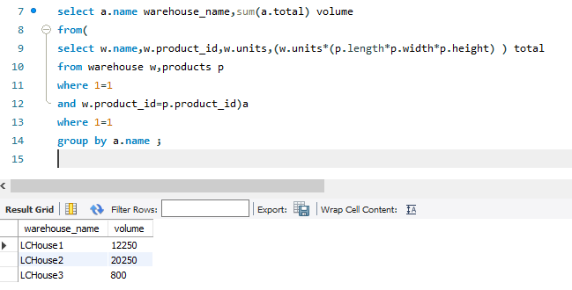

# Q42.

Table: Sales

|  |  |
| --- | --- |
| Column Name | Type |
| sale_date | date |
| fruit | enum |
| sold_num | int |

(sale_date, fruit) is the primary key for this table.

This table contains the sales of "apples" and "oranges" sold each day.

Write an SQL query to report the difference between the number of apples and oranges sold each day. Return the result table ordered by sale_date.

The query result format is in the following example.

Input:

Sales table:

|  |  |  |
| --- | --- | --- |
| sale_date | fruit | sold_num |
| 2020-05-01 | apples | 10 |
| 2020-05-01 | oranges | 8 |
| 2020-05-02 | apples | 15 |
| 2020-05-02 | oranges | 15 |
| 2020-05-03 | apples | 20 |
| 2020-05-03 | oranges | 0 |
| 2020-05-04 | apples | 15 |
| 2020-05-04 | oranges | 16 |

Output:

|  |  |
| --- | --- |
| sale_date | diff |
| 2020-05-01 | 2 |
| 2020-05-02 | 0 |
| 2020-05-03 | 20 |
| 2020-05-04 | -1 |

Explanation:

Day 2020-05-01, 10 apples and 8 oranges were sold (Difference 10 - 8 = 2).

Day 2020-05-02, 15 apples and 15 oranges were sold (Difference 15 - 15 = 0).

Day 2020-05-03, 20 apples and 0 oranges were sold (Difference 20 - 0 = 20).

Day 2020-05-04, 15 apples and 16 oranges were sold (Difference 15 - 16 = -1).

**Answer:**

create table sales

(

sale_date date,

fruit enum('apples','oranges'),

sold_num int,

primary key(sale_date,fruit)

);

insert into sales (sale_date,fruit,sold_num) values

('2020-05-01','apples',10),

('2020-05-01','oranges',8),

('2020-05-02','apples',15),

('2020-05-02','oranges',15),

('2020-05-03','apples',20),

('2020-05-03','oranges',0),

('2020-05-04','apples',15),

('2020-05-04','oranges',16);

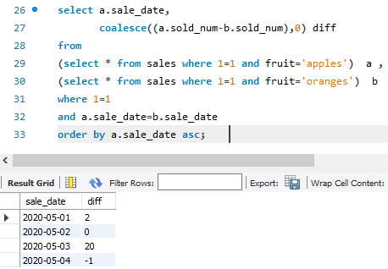

# Q43.

Table: Activity

|  |  |
| --- | --- |
| Column Name | Type |
| player_id | int |
| device_id | int |
| event_date | date |
| games_played | int |

(player_id, event_date) is the primary key of this table. This table shows the activity of players of some games.

Each row is a record of a player who logged in and played a number of games (possibly 0) before logging out on someday using some device.

Write an SQL query to report the fraction of players that logged in again on the day after the day they ﬁrst logged in, rounded to 2 decimal places. In other words, you need to count the number of players that logged in for at least two consecutive days starting from their ﬁrst login date, then divide that number by the total number of players.

The query result format is in the following example.

Input: Activity table:

|  |  |  |  |
| --- | --- | --- | --- |
| player_id | device_id | event_date | games_played |
| 1 | 2 | 2016-03-01 | 5 |
| 1 | 2 | 2016-03-02 | 6 |
| 2 | 3 | 2017-06-25 | 1 |
| 3 | 1 | 2016-03-02 | 0 |
| 3 | 4 | 2018-07-03 | 5 |

Output:

0.33

fraction

Explanation:

Only the player with id 1 logged back in after the ﬁrst day he had logged in so the answer is 1/3 = 0.33

**Answer:**

create table activity

(

player_id int,

device_id int,

event_date date,

games_played int,

primary key(player_id,event_date)

);

insert into activity(player_id,device_id,event_date,games_played) values

(1,2,'2016-03-01',5),

(1,2,'2016-03-02',6),

(2,3,'2017-06-25',1),

(3,1,'2016-03-02',0),

(3,4,'2018-07-03',5);

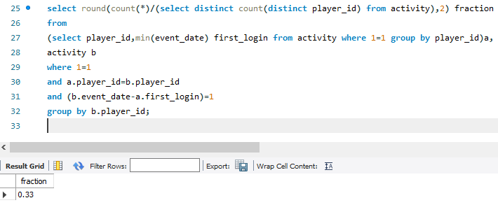

# Q44.

Table: Employee

|  |  |
| --- | --- |
| Column Name | Type |
| id | int |
| name | varchar |
| department | varchar |
| managerId | int |

id is the primary key column for this table.

Each row of this table indicates the name of an employee, their department, and the id of their manager.

If managerId is null, then the employee does not have a manager. No employee will be the manager of themself.

Write an SQL query to report the managers with at least ﬁve direct reports. Return the result table in any order.

The query result format is in the following example.

Input: Employee table:

|  |  |  |  |
| --- | --- | --- | --- |
| id | name | department | managerId |
| 101 | John | A | None |
| 102 | Dan | A | 101 |
| 103 | James | A | 101 |
| 104 | Amy | A | 101 |
| 105 | Anne | A | 101 |
| 106 | Ron | B | 101 |

Output:

John

name

**Answer:**

create table employee

(

id int,

name varchar(30),

department varchar(30),

manager_id int,

primary key (id)

);

insert into employee (id,name,department,manager_id) values

(101,'John','A',null),

(102,'Dan','A',101),

(103,'James','A',101),

(104,'Amy','A',101),

(105,'Anne','A',101),

(106,'Ron','B',101);

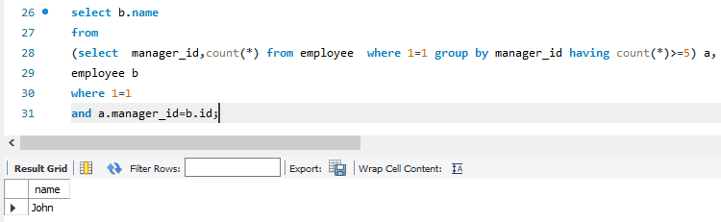

# Q45.

Table: Student

|  |  |
| --- | --- |
| Column Name | Type |
| student_id | int |
| student_name | varchar |
| gender | varchar |
| dept_id | int |

student_id is the primary key column for this table.

dept_id is a foreign key to dept_id in the Department tables.

Each row of this table indicates the name of a student, their gender, and the id of their department.

Table: Department

|  |  |
| --- | --- |
| Column Name | Type |
| dept_id | int |
| dept_name | varchar |

dept_id is the primary key column for this table.

Each row of this table contains the id and the name of a department.

Write an SQL query to report the respective department name and number of students majoring in each department for all departments in the Department table (even ones with no current students). Return the result table ordered by student_number in descending order. In case of a tie, order them by dept_name alphabetically.

The query result format is in the following example.

Input: Student table:

|  |  |  |  |
| --- | --- | --- | --- |
| student_id | student_name | gender | dept_id |
| 1 | Jack | M | 1 |
| 2 | Jane | F | 1 |
| 3 | Mark | M | 2 |

Department table:

|  |  |
| --- | --- |
| dept_id | dept_name |
| 1 | Engineering |
| 2 | Science |
| 3 | Law |

Output:

|  |  |
| --- | --- |
| dept_name | student_numbe r |
| Engineering | 2 |
| Science | 1 |
| Law | 0 |

**Answer:**

create table department

(

dept_id int,

dept_name varchar(30),

primary key (dept_id)

);

create table student

(

student_id int,

student_name varchar(30),

gender varchar(30),

dept_id int,

primary key (student_id),

foreign key (dept_id) references department(dept_id)

);

insert into department(dept_id,dept_name) values

(1,'Engineering'),

(2,'Science'),

(3,'Law');

insert into student (student_id,student_name,gender,dept_id) values

(1,'Jack','M',1),

(2,'Jane','F',1),

(3,'Mark','M',2);

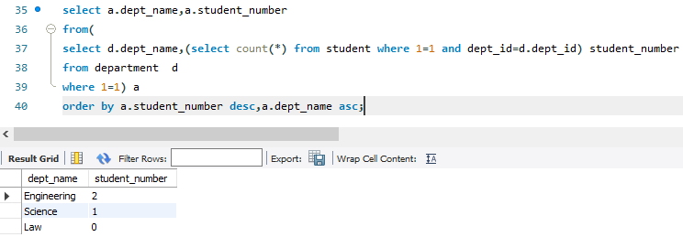

# Q46.

Table: Customer

|  |  |
| --- | --- |
| Column Name | Type |
| customer_id | int |
| product_key | int |

There is no primary key for this table. It may contain duplicates. product_key is a foreign key to the Product table.

Table: Product

|  |  |
| --- | --- |
| Column Name | Type |
| product_key | int |

product_key is the primary key column for this table.

Write an SQL query to report the customer ids from the Customer table that bought all the products in the Product table.

Return the result table in any order.

The query result format is in the following example.

Input: Customer table:

|  |  |
| --- | --- |
| customer_id | product_key |
| 1 | 5 |
| 2 | 6 |
| 3 | 5 |
| 3 | 6 |
| 1 | 6 |

Product table:

|  |
| --- |
| product_key |
| 5 |
| 6 |

Output:

|  |
| --- |
| customer_id |
| 1 |
| 3 |

**Answer:**

create table product

(

product_key int,

primary key (product_key)

);

create table customer

(

customer_id int,

product_key int,

foreign key (product_key) references product(product_key)

);

insert into product(product_key) values

(5),

(6);

insert into customer (customer_id,product_key) values

(1,5),

(2,6),

(3,5),

(3,6),

(1,6);

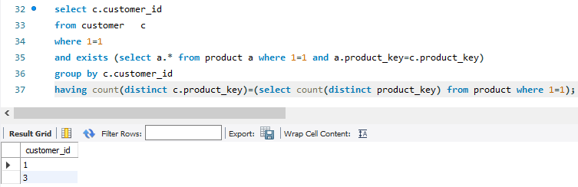

# Q47.

Table: Project

|  |  |
| --- | --- |
| Column Name | Type |
| project_id | int |
| employee_id | int |

(project_id, employee_id) is the primary key of this table. employee_id is a foreign key to the Employee table.

Each row of this table indicates that the employee with employee_id is working on the project with project_id.

Table: Employee

|  |  |
| --- | --- |
| Column Name | Type |
| employee_id | int |
| name | varchar |
| experience_yea rs | int |

employee_id is the primary key of this table.

Each row of this table contains information about one employee.

Write an SQL query that reports the most experienced employees in each project. In case of a tie, report all employees with the maximum number of experience years.

Return the result table in any order.

The query result format is in the following example.

Input: Project table:

|  |  |
| --- | --- |
| project_id | employee_id |
| 1 | 1 |
| 1 | 2 |
| 1 | 3 |
| 2 | 1 |
| 2 | 4 |

Employee table:

|  |  |  |
| --- | --- | --- |
| employee_id | name | experience_yea rs |
| 1 | Khaled | 3 |
| 2 | Ali | 2 |
| 3 | John | 3 |
| 4 | Doe | 2 |

Output:

|  |  |
| --- | --- |
| project_id | employee_id |
| 1 | 1 |
| 1 | 3 |
| 2 | 1 |

Explanation:

Both employees with id 1 and 3 have the most experience among the employees of the ﬁrst project. For the second project, the employee with id 1 has the most experience.

**Answer:**

create table employee

(

employee_id int,

name varchar(30),

experience_years int,

primary key (employee_id)

);

create table project

(

project_id int,

employee_id int,

primary key (project_id,employee_id),

foreign key (employee_id) references employee(employee_id)

);

insert into employee(employee_id,name,experience_years) values

(1,'Khaled',3),

(2,'Ali',2),

(3,'John',3),

(4,'Doe',2);

insert into project (project_id,employee_id) values

(1,1),

(1,2),

(1,3),

(2,1),

(2,4);

select distinct a.project_id,b.employee_id

from

(select p.project_id,

max(e.experience_years) years

from project p, employee e

where 1=1

and p.employee_id=e.employee_id

group by p.project_id ) a ,

(select p.project_id,e.employee_id,e.experience_years

from project p,employee e

where 1=1

and p.employee_id=e.employee_id ) b

where 1=1

and a.project_id=b.project_id

and a.years=b.experience_years

order by project_id asc;

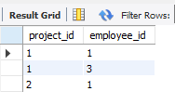

# Q48.

Table: Books

|  |  |
| --- | --- |
| Column Name | Type |
| book_id | int |
| name | varchar |
| available_from | date |

book_id is the primary key of this table.

Table: Orders

|  |  |
| --- | --- |
| Column Name | Type |
| order_id | int |
| book_id | int |
| quantity | int |
| dispatch_date | date |

order_id is the primary key of this table. book_id is a foreign key to the Books table.

Write an SQL query that reports the books that have sold less than 10 copies in the last year, excluding books that have been available for less than one month from today. Assume today is 2019-06-23.

Return the result table in any order.

The query result format is in the following example.

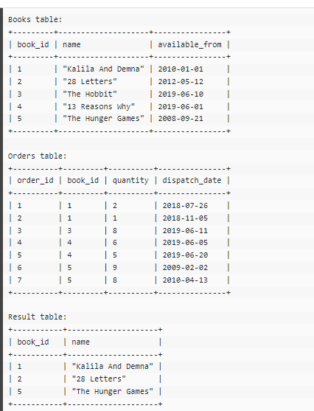

**Answer:**

create table books

(

book_id int,

name varchar(30),

available_from date,

primary key (book_id)

);

create table orders

(

order_id int,

book_id int,

quantity int,

dispatch_date date,

primary key (order_id),

foreign key (book_id) references books(book_id)

);

insert into books(book_id,name,available_from) values

(1,'Kalila And Demna','2010-01-01'),

(2,'28 Letters','2012-05-12'),

(3,'The Hobbit','2019-06-10'),

(4,'13 Reasons Why','2019-06-01'),

(5,'The Hunger Games','2008-09-21');

insert into orders (order_id,book_id,quantity,dispatch_date) values

(1,1,2,'2018-07-26'),

(2,1,1,'2018-11-05'),

(3,3,8,'2019-06-11'),

(4,4,6,'2019-06-05'),

(5,4,5,'2019-06-20'),

(6,5,9,'2009-02-02'),

(7,5,8,'2010-04-13');

select a.book_id,a.name

from(

select b.book_id,b.name,sum(o.quantity) quantity

from books b,

orders o

where 1=1

and b.book_id=o.book_id

and b.available_from<'2019-05-23'

and o.dispatch_date between '2018-06-23' and '2019-06-23'

group by b.book_id,b.name

having sum(o.quantity)<10) a

union

select b.book_id,b.name

from books b

where 1=1

and b.available_from<'2019-05-23'

and not exists (select * from orders o where 1=1 and o.book_id=b.book_id

and o.dispatch_date between '2018-06-23' and '2019-06-23') ;

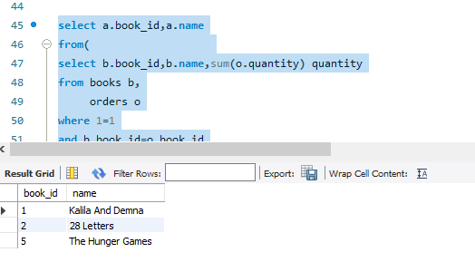

# Q49.

Table: Enrollments

|  |  |
| --- | --- |
| Column Name | Type |
| student_id | int |
| course_id | int |
| grade | int |

(student_id, course_id) is the primary key of this table.

Write a SQL query to ﬁnd the highest grade with its corresponding course for each student. In case of a tie, you should ﬁnd the course with the smallest course_id.

Return the result table ordered by student_id in ascending order. The query result format is in the following example.

Input: Enrollments table:

|  |  |  |
| --- | --- | --- |
| student_id | course_id | grade |
| 2 | 2 | 95 |
| 2 | 3 | 95 |
| 1 | 1 | 90 |
| 1 | 2 | 99 |
| 3 | 1 | 80 |
| 3 | 2 | 75 |
| 3 | 3 | 82 |

Output:

|  |  |  |
| --- | --- | --- |
| student_id | course_id | grade |
| 1 | 2 | 99 |
| 2 | 2 | 95 |
| 3 | 3 | 82 |

**Answer:**

create table enrollments

(

student_id int,

course_id int,

grade int,

primary key (student_id,course_id)

);

insert into enrollments(student_id,course_id,grade) values

(2,2,95),

(2,3,95),

(1,1,90),

(1,2,99),

(3,1,80),

(3,2,75),

(3,3,82);

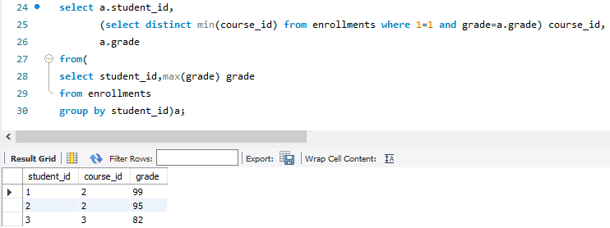

# Q50.

Table: Teams

|  |  |
| --- | --- |
| Column Name | Type |
| team_id | int |
| team_name | varchar |

team_id is the primary key of this table.

Each row of this table represents a single football team.

Table: Matches

|  |  |
| --- | --- |
| Column Name | Type |
| match_id | int |
| host_team | int |
| guest_team | int |
| host_goals | int |
| guest_goals | int |

match_id is the primary key of this table.

Each row is a record of a ﬁnished match between two different teams.

Teams host_team and guest_team are represented by their IDs in the Teams table (team_id), and they scored host_goals and guest_goals goals, respectively.

The winner in each group is the player who scored the maximum total points within the group. In the case of a tie, the lowest player_id wins.

Write an SQL query to ﬁnd the winner in each group. Return the result table in any order.

The query result format is in the following example.

Input: Players table:

|  |  |
| --- | --- |
| player_id | group_id |
| 15 | 1 |
| 25 | 1 |
| 30 | 1 |
| 45 | 1 |
| 10 | 2 |
| 35 | 2 |
| 50 | 2 |
| 20 | 3 |
| 40 | 3 |

Matches table:

|  |  |  |  |  |
| --- | --- | --- | --- | --- |
| match_id | ﬁrst_player | second_player | ﬁrst_score | second_score |

|  |  |  |  |  |
| --- | --- | --- | --- | --- |
| 1 | 15 | 45 | 3 | 0 |
| 2 | 30 | 25 | 1 | 2 |
| 3 | 30 | 15 | 2 | 0 |
| 4 | 40 | 20 | 5 | 2 |
| 5 | 35 | 50 | 1 | 1 |

Output:

|  |  |
| --- | --- |
| group_id | player_id |
| 1 | 15 |
| 2 | 35 |
| 3 | 40 |

**Answer:**

create table players

(

player_id int,

group_id int

);

create table matches

(

match_id int,

first_player int,

second_player int,

first_score int,

second_score int

);

insert into players (player_id,group_id) values

(15,1),

(25,1),

(30,1),

(45,1),

(10,2),

(35,2),

(50,2),

(20,3),

(40,3);

insert into matches (match_id,first_player,second_player,first_score,second_score) values

(1,15,45,3,0),

(2,30,25,1,2),

(3,30,15,2,0),

(4,40,20,5,2),

(5,35,50,1,1);

select group_id,player_id

from (

select sc.group_id group_id, sc.player_id player_id,

rank() over (partition by sc.group_id order by sum(sc.score) desc, sc.player_id asc) as rnk

from(

select p.group_id group_id,

p.player_id player_id ,

sum(m.first_score) as score

from players p

inner join matches m

on p.player_id = m.first_player

group by p.group_id,p.player_id

union all

select p.group_id group_id,

p.player_id player_id ,

sum(second_score) as score

from players p

inner join matches m

on p.player_id = m.second_player

group by p.group_id,p.player_id

) sc

group by sc.group_id,sc.player_id

) A

where rnk = 1

